**BTEC Extended Certificate**

In Creative Digital Media Production

**UNIT 9: Digital Editing for Moving Image**

Investigate the different ways that editors join together the shots so that they make sense, convey meaning and create audience response

**Learner’s Name: Aaron Coleman**

**Learner declaration**

I certify that the evidence submitted for this assignment is my own. I have clearly referenced any sources used in the work. I understand that false declaration is a form of malpractice.

**Learner signature: acoleman313@howcollege.ac.uk**

**Date: 2/03/2016**

# Introduction

In the early days of cinema editing was almost non-existent but over time it grew and as technology progressed so did the methods of editing transitions and camera movements which nowadays is no big deal but during the early days those were unheard of it wasn’t until a trip to the moon (1902) that had some of the first transitions used and eve that was very basic cutting also all cinema product were told in a linear narrative no backstory or flash backs just one way such as a trip to the moon which only went forward there was no story on why they were going to the moon.

# Pioneers of film editing technique and style

## Techniques

Editing in the camera is where all the shots are done in the precise order they will be developed this takes a lot of planning to not mess up and to get the perfect film but because there was no editing a mess up could make the hole shot have to be done over it was easy to do you film something and the second you are finished it was a finished film an example of this is with the L'arrivée d'un train en gare de La Ciotat which is a 48 second short film where a train pulls into a station .cutting at the workbench is were parts of the film are cut to make the film shorter or to cut to an entirely different scene this is a transition one of the first times this was done was in the short film a trip to the moon in which they took mini transitions when building the gun as filming the trip to the scene would have taken away from the entertainment so cutting is good to keep the movie going and make it more entertaining.

## Style

Surreal editing is using special effects in films this can be using a fire to blow smoke or steam into the scene this can make the impression of something like an off screen explosion the smoke makes the consumers’ minds have more immersion as its more realistic instead of a screen with no special effects that nothing seems entertaining because there’s nothing special or entertaining happening special effects can make a normal situation seem spectacular you can see an example of surreal editing in a trip to the moon 1902 in which they are building a gun where they put smoke blowing into the main room as if they were actually wielding and smelting which gave a more immersive experience for the time that the movie was made continuity editing is different from this as in which the director is trying to make the film seem as real as possible by making the scene so much like the real world around us so that the consumer can understand what is happening 0on screen special effects are not used much in this form of editing.

# Technical developments in editing

The first print that was used was celluloid print which is a substance that is easily moulded and was used when the film industry was first conceived up until the early 21st century when more digital forms are taking over, people could edit celluloid print in a small number of ways such as cutting and splicing which was cutting the film in two places and fixing them together to create a transition another editing they use more recently is digital intermediate in which a film is digitized to manipulate the colours and other characteristics to make the film appear more appealing negative is also a form of editing done at the end of a production in which the bits of the film that are not supposed to be in the final edit are cut. Television and videos is edited it different to films as it is on a different format and also because in the days of early television reels of each show could not be disturbed to every house one of the ways videos and television was edited was with reel-to-reel videotape editing which involves putting the wheel on a spindle and slowly feeding it though then cutting out the bits that are not needed to make the final product fit another form of television editing is multi-camera editing in which 2 or more cameras are recording at the same time this allows for the cameras to switch for close ups on different characters or to record the characters exiting one room and entering another this gives a more realistic and immersive experience and is mostly used in sitcoms and reality television live editing or studio editing is where the editing is done in a studio though adding special effects with a vision mixer to make the finished product.

Offline editing happens in the post production part of film making and requires coping and editing raw footage without affecting the original video tape since the coming of the digital age though this part of filmmaking has been is more easily done with the comings of new technology. Once offline editing has been finished online editing can take place which is when a video editor is used to add the last effects. Linear editing is editing and arranging images and sounds in a predetermined order while non-linear is being able to access any frame without this is easier for transition as a transition can be put wherever you see fit and this has been used a lot within the past few years for things like flash backs and non-linear timelines.

# The purpose of editing

During editing time is everything how fast or slow something goes can make or break the film one of the main things used to build up suspense is slow motion in which the film is slowed down a bit to give more time for suspense to build. Another thing that helps the consumer understand a movie is flashbacks as a flashback could give a little more backstory to a place or character making the consumer more involved in the film time is also used to determine how long the final product will run moves averagely 90 minutes it would be unwise to have one that is 4 hours long so bits are snipped out and the most exciting or informative peace’s of the movie are used to keep it entertaining. Space within films is important if one character is in the shot but there are two character in a room it is important to show the character is still them as to not confuse the consumer this is done by the character talking when they are not in the shot or by quick flickers to their reactions to different things that happen in the image with movies the length of the shot cannot be to short or long if it is too long then it can bore the audience but if it’s too short then the audience will not be able to understand what has transpired all h shots have to flow and work together you cannot just have a bunch of shots throw them into one and expect a perfect movie the movie has to make sense and flow.

# Classic Continuity Editing

In the field of digital media products need to use techniques like transition to keep the viewer interested transitions can be done in a number of ways and can easily keep someone hooked because they want to know what happens next. With these techniques there are two types of editing invisible and seamless are the same thing there just two names for the same technique in which is to make the film seem like it has not even been edited this is done by using a few things the 180 degree rule keeps one camera facing at one direction so there’s no switching which may make the audience slightly confused as well as this the cuts are made so there are no sudden cuts so it’s like there’s been no editing the reason it’s called invisible editing.

## Continuity techniques

There are many different types of continuity techniques one of which is the 180 degree rule which is where there is one camera at one angle as to not to confuse the audience.

[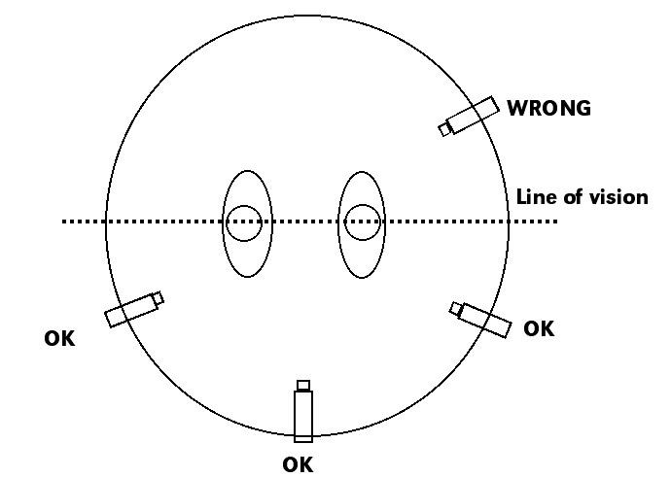](http://www.google.co.uk/url?sa=i&rct=j&q=&esrc=s&source=images&cd=&cad=rja&uact=8&ved=0ahUKEwiKppmegsXLAhWlHJoKHacfA0oQjRwIBw&url=http://expertinediting1.blogspot.com/2012/06/180-degree-rule.html&psig=AFQjCNE2t_N_pj7J64o8Qr0o8jixbwAdoQ&ust=1458211031842840)

The eye-line match is when two subjects are looking at each other in the same room and on camera this then builds up suspense and takes the viewers minds off the editing that has been used.

[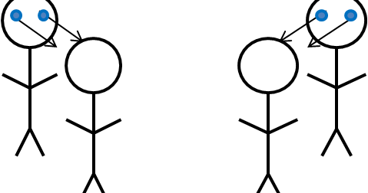](http://www.google.co.uk/url?sa=i&rct=j&q=&esrc=s&source=images&cd=&cad=rja&uact=8&ved=0ahUKEwjRh-ndh8XLAhWkHJoKHW3nBFQQjRwIBw&url=http://tiahnorris.blogspot.com/2012/10/eyeline-match.html&bvm=bv.116954456,d.d24&psig=AFQjCNFCpYdgYMUBJ_RISxWRTDLNe_DCEA&ust=1458212680699216)

The 30 degree rule is the rule that the camera must move at least 30 degrees with each shot of the same subject if this does not happen then there will be a jump cut and the audience will then start focusing on the editing technique me instead of the story of the film.

[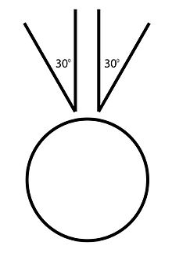](https://en.wikipedia.org/wiki/File:The-30-degree-rule-and-stereo-vision.jpg)

**Transitions and their meanings**

There are 4 main types of transitions I’ll be going over two. the first one will be the dissolve which is a gradual transition between two pictures this is mostly used to remember people or at the end of credits or presentations this gives a more gradual feeling and is more emotional viewer plus it insures that the viewer will remember the character or person. The second I will be talking about is the fade this is usually used to fade to black to signify the end of the film but it can also be used to fade between two different images or scenes to create tension or emphasis on the finality of a scene or charter it is used at the end of the film because it makes things seem final as there is nothing else to say an example of this is in the movie deadpool at the end it fades to black as to say that that is the end.

**Editing terminology**

The first thing that is done to do with editing is the set-ups this Is where the cameras are positioned to give different angles when people move these cameras all record and then the film is cut to use the cameras that are needed at that pacific moment this can keep all the characters on camera as to not confuse the audience because someone is talking and cannot see them. Takes is another thing that is done after this is where the same scene is done over and over again to get the perfect when it is the remaining shots are thrown out then the shots are picked out of the amount of takes that were done a scene is a collection of the best shots that are put to gather into a different scene scenes keep films interesting and give an easier way to pick out imperfections at a certain moment also when a scene changes it is usually right after a big moment or right before as to build up suspense for the viewer rushes are when unedited footage is used because it is good enough and no editing is needed.

# .Technical developments in editing

There is also alternative styles of editing such as montage and new wave editing which will be covered here montage editing is when a group of images is shown in succeed to make a certain feeling or to remember someone such as at the end of a movie credits where it shows pictures and then in loving memory of. New wave editing this is a French technique which is used to make a very expressive film it does this by using long tracking shots this technique is used to stress the individual and to make acceptance of the abusdence of humanity some other things that are done with editing are things such as slow motion this is used to create suspense as everything on the screen is slowed so the view can see everything but because it takes longer for the scene to end everything in the scene can be assessed and taken in visual effects such as special fx or cgi are used to do the impossible this are usually done in sci fi horror or action genres to make things such as explosions and things like that happen without actually doing it making the film seem more realistic and exciting. Split-screen editing is where two moments are shown on the same screen this can make the viewer feel like they are there as they can see it from both sides this is usually used during phone conversations. Freeze frames are when the movie freezes completely for a few seconds this is so the audience can properly grasp what is going on in the movie they use this in action movies such as the matrix the last thing I will be talking about is speeded up shots which is when he film speeds up this is used in action movies during a chase or when a movie fast forwards to a point in time

# References

1st image [expertinediting1.blogspot.com](http://www.google.co.uk/url?sa=i&rct=j&q=&esrc=s&source=images&cd=&cad=rja&uact=8&ved=0ahUKEwiKppmegsXLAhWlHJoKHacfA0oQjB0IBg&url=http%3A%2F%2Fexpertinediting1.blogspot.com%2F2012%2F06%2F180-degree-rule.html&psig=AFQjCNE2t_N_pj7J64o8Qr0o8jixbwAdoQ&ust=1458211031842840) date accessed 16/03/2016

2nd [www.emaze.com](http://www.emaze.com) date accessed 16/03/2016

3rd image en.wikipedia.org date accessed 16/03/2016